Timeline & Overview:
our Ancestors’ immmigration to the New England Colonies
& EMigration from New England to Nova Scotia
By Cathy Eaton, November 10 , 2019

New England Planters
The original New England Planters left their homes “in the midlands and south of England” during the mid-sixteen hundreds “to plant a new England on the Atlantic coast of North America.” They were called Pilgrims or Puritans. Their religious, political, and economic motivations led them to risk the hazardous crossing of the Atlantic Ocean to carve out a new life in the wilderness of England’s colonies on the eastern coast of America.” “The name Planters was an Elizabethan term for colonists. They were not people who planted crops, they were people who planted colonies.” Some of those loyal to the crown headed to Nova Scotia. Those who emigrated before American Revolution were called Planters; those who came after the Revolution were called Loyalists.

Our first confirmed Eaton ancestors John Eaton (b. 12.26.1590, Hatton, Warwickshire, England; d. 10.29.1668, Salisbury, MA) and Anne (b. 1599 in England, d. 2.5.1660 in Haverhill, MA) arrived with six children in Salisbury, Massachusetts Bay Colony, in the winter of 1639 or 1640. This Eaton family carved out a life, built homes, farmed the land, and helped established towns in the English colony of Massachusetts. After four generations and a 120 years later, their descendent David Eaton migrated with his family to the western coast of Nova Scotia, home to the Mi’kmaq for centuries and home to the French Acadians for 150 years.

Our ancestors who arrived primarily from England but also Scotland, Ireland, Wales, Prussia, and Portugal, by the names of White, Singletery, Cooke, Sanders, Kimball, Atwood, Woodworth, Fox, Harris, DeWolf, Parker, Spurr, Maynard, McPherson, Akerley, Doherty, and Demings settled first in the colonies of Connecticut, Massachusetts, and Rhode Island before some family members also emigrated to Nova Scotia.

NATIVE AMERICANS
For a century before Europeans arrived, Native Americans, who initially survived through hunting and gathering, had roamed New England. “Migrating here after the retreat of the last ice age, by 1500 they had a population likely in excess of 100,000…They had become more agricultural – with extensive fields of corn (maize), beans, and squash. By this time the tribes were fundamentally stationary, but shifted dwellings several times year based on weather – winter, autumn hunting, and summer. The New England tribes had a common heritage and belonged to the Algonquian family. Their language was fairly common, and although each tribe had nuances, there was the ability to be understood from Cape Cod to Canada.”

In three brief years between 1616 and 1619, disease that escalated to a plague, called the ‘Great Dying,’ decimated “¾ of the New England Native American population, with the devastation worse in the coastal areas where mortality was as high as 95%.” The white colonists carried the disease across the ocean, and the Native Americans had no resistance. “ Over the centuries theories of the mass extinction “have included yellow fever, smallpox, and plague. Chickenpox and trichinosis are among more recent proposals.” Most recently another explanation has emerged: an infectious disease, called leptospirosis, carried by rodents travelling on ships of the European migrants. Consequently, the white settlers arriving around 1620, “encountered very little of the indigenous population.”

ENGLISH SETTLERS
“At the start of the seventeenth century, the English had not established a permanent settlement in the Americas. Over the next century, however, they outpaced their rivals. The English encouraged emigration far more than the Spanish, French, or Dutch. They established nearly a dozen colonies, sending swarms of immigrants to populate the land. England had experienced a dramatic rise in population in the sixteenth century, and the colonies appeared a welcoming place for those who faced overcrowding and grinding poverty at home. Thousands of English migrants arrived in the Chesapeake Bay colonies of Virginia and Maryland to work in the tobacco fields. Another stream, this one of pious Puritan families, sought to live as they believed scripture demanded and established the Plymouth, Massachusetts Bay, New Haven, Connecticut, and Rhode Island colonies of New England.”

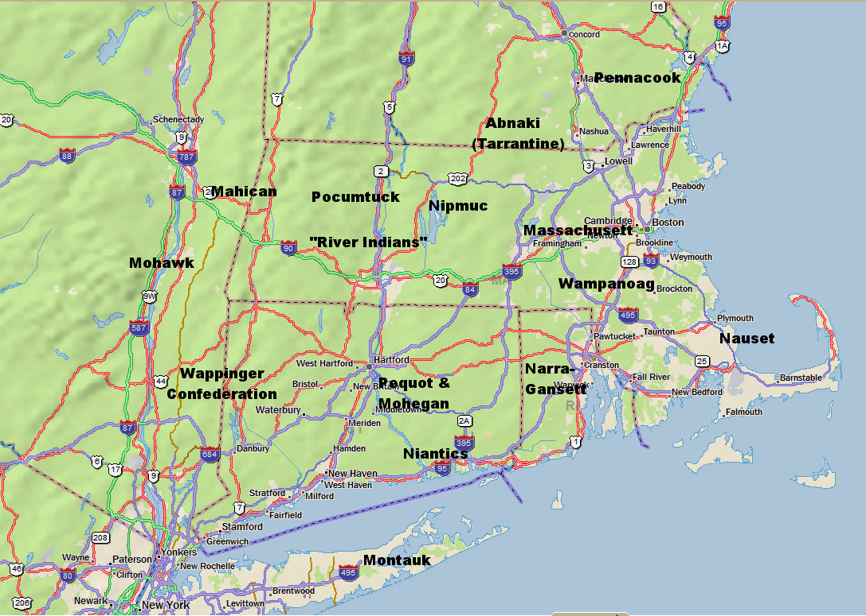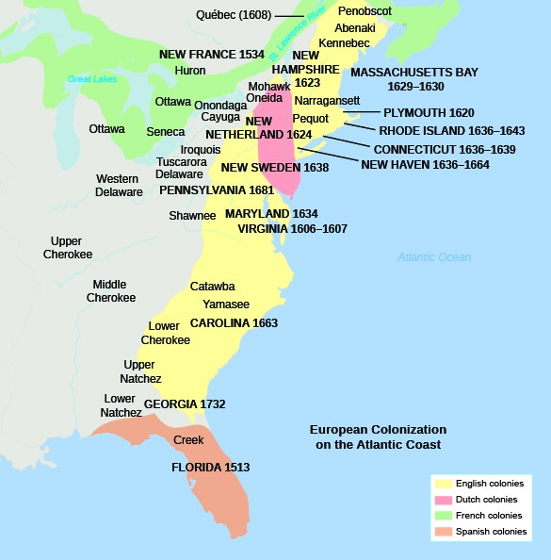
The Abnaki, also known as the Tarrantine to other tribes, inhabited western Maine. The Penacook inhabited southern and central MA, northeastern MA and southeastern ME, with the principle subdivision around Concord, NH. The Penacook had many subordinate tribes including the Nashua, Piscataqua, and the Winnepesaukee. The Massachusett (in Algonquian, “people of the great hills”), from whom the state of Massachusetts got its name, inhabited the eastern area of state, around Boston. The Wampanoag inhabited the areas of southeastern Massachusetts near where the Pilgrims landed in current Plymouth. The Nipmucs and the Pocumtucks also lived in Massachusetts. The Narragansetts lived in present-day Rhode Island. The Niantics were a largely coastal tribe lived on Narragansett Bay, and extended as far west as the Pequot tribe in Connecticut. The Pequots, of eastern Connecticut were originally part of the Mahican (known as Mohegan, a corruption of the Mahigan name) a tribe of the of upper Hudson River valley in New York. South of the Pocumtucks along the Connecticut River Valley lived the “River Indians”, another loose association of tribes.

THE ACADIANS
Before any of our ancestors reached the American Colonies, the Acadians began arriving from France to what is now called Nova Scotia, New Brunswick, and Prince Edward Island when Samuel Champlain established a settlement in 1605 around the time the English founded Virginia in 1607. The Acadians reclaimed tidal flats around the Bay of Fundy to establish their farms and orchards, an effort that required strong community cooperation. They traded with the Indigenous people, colonists in New England, and French settlers in Quebec and Cape Breton. Family connections and the Catholic church created strong bonds within the Acadian community; simultaneously, the Acadians formed positive relationships and intermarried with the Indigenous groups, including the Mi’kmaw, the Malecite, and Abenaki peoples. This land called Acadia flipped back and forth between the French and the English between 1610 and 1755 when the Acadians were ripped from their homes and cruelly deported.

THE MI’KMAQ
For hundreds of year before the settling of the Acadians, the Mi’kmaq in the Maritime Provinces had sustained their way of life primarily through hunting and fishing in the winter with small family groups and in the spring and summer with larger camps of numerous families. Their portable birchbark-covered wigwams accommodated a dozen to two dozen people. While each of seven districts had its own chief, their grand chief dwelled on Cape Breton Island. Contact and trade with Europeans brought them iron items such as knives and a variety of foods not healthy for their diet as well as killing diseases like small pox. The Mi’kmaq assisted the Acadians by sharing hunting and fishing techniques and teaching them methods to make clothes and canoes as well as how to insulate their homes. “Traditionally, the Mi’kmaq geographic boundaries included Nova Scotia, Prince Edward Island, large areas of New Brunswick, and the Gaspe Bay in Quebec. The seven districts known as Kespe’k (New Brunswick and Gaspe Bay in Quebec), Epekwitk aq Piktuk (P.E.I.), Sipekne’katik (Shubenacadie), Kespukwitk(southwestern Nova Scotia/Yarmouth), Umama’kak (Cape Breton). Siknikt (Miramichi/Bay of Fundy), Eskikewa’kik (Sheet Harbour to Canso) were the traditional territories of the Mi’kmaq Peoples.”

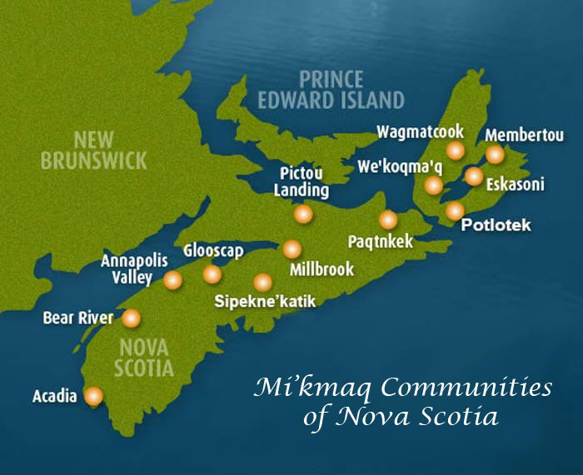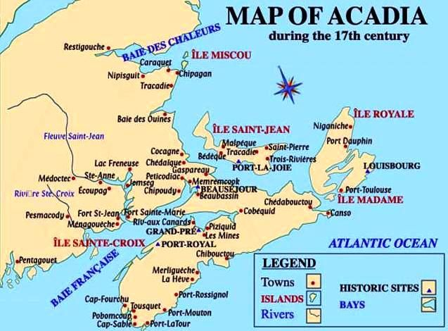
The Mi’kmaq tribes & lands The Acadian lands & towns

“The Mi’kmaq worldview is relational, where everything existed within a network of relationships and could not exist as a separate entity outside of those relationships. On all levels of reality, visible and invisible, everything is related. As everyone and everything is related, proper decorum was expected because it was thought that if you harmed someone or something, you ultimately harmed yourself in the process. One cannot take these relationships for granted, rather each person must express honor and respect in their relationships with others. This worldview extends to all human relationships, the environment, the animals, and to other beings. Mi’kmaq ancestors understood that everything is in a continuous state of flux, ever changing and non-static. The constant motion signifies that everything is in the process of becoming. It is also understood that these relationships require renewal ceremonies in order to sustain and maintain balance and harmony through the life cycles.”

Timeline in Annapolis Royal of Arrival & Deportation of Acadians, Arrival of Planters, & Arrival of Loyalists
1605 – Champlain established first settlement.
1713 – Nova Scotia became. British colony
1745 – British captured French held Fort Louisburg in Cape Breton; 1758- Surrender of Louisburg
1755 – Capture of Fort Beausejour
1755 - The Acadian Deportation commenced.
The Acadians men, women, and children were rounded up, deprived of most of their possessions, and deported to colonies on the east coast of America where they were not welcomed and where they had no live stock or cargo to help them build new homesteads.
12 October 1758 - The first proclamation was sent out by Lieutenant General Lawrence calling for New England immigrants to send settlement inquiries for the available Acadian lands of Nova Scotia.
11 January 1759 - The second proclamation was issued by Lieutenant General Lawrence addressing the initial concerns Planters had about immigrating to Nova Scotia. Townships of over 100,000 acres began to be established to contain.
Our ancestor Hannah Almira Morris’s grandfather, Surveyor-General Charles Morris accompanied agents to investigate potential land grants to the Planters. “The agents set out on a Government ship with the Survey-General in command…The vessel sailed around Yarmouth into the Bay of Fundy which enabled the visitors to view the lands along the Annapolis River before proceeding to Minas Basin. They landed on the shore of the Basin and spent many busy days studying the topography and soil of the large area between Cape Blomindon and Piziquid, now Windsor. They were delighted with all they saw. Seven rivers emptied their waters into the Basin, and on the banks of each was an abundance of fertile soil. The hills were covered with forests and the apple trees planted by the Acadians were almost ready to bud, the grass on the dykes was green, and the uplands seemed to waiting for the plow….The now enthusiastic agents were quite ready to settle two townships, Horton and Cornwallis, each of 100,000 acres, with 200 and 150 families respectively. These were to be brought to Nova Scotia at Government expense, and each passenger might bring stock, tools, building materials, and household goods up to a weight of two tons.”
November 1759 - A terrible storm hit Nova Scotia affecting the flow of immigrants into Annapolis, Minas, and Chignecto. Here the advanced dyke systems was destroyed, cause immense tracts of land to be flooded with salt waters and consequently unable to bear grain crops for the next three years. A decision was made to check the effects of the damage before the migration of the New Englanders, delaying their migration to 1760.
1759-1760 – Planters from Connecticut and Massachusetts as well as Rhode Island hold a series of meetings in their towns where they were recruited to move to the Annapolis Valley.
Soldier ancestors from the colonies who fought in Canada before migrating there.
It is likely that David Eaton, the founder of our Nova Scotia Eaton family, ventured into Canada between June 1759 and November 1759 and again for several months the following year with the English militia. Although other family members, like his brothers Timothy and Nathaniel, who fought for the colonists and chose to remain in New England, David and his wife Deborah White abandoned their home in Tolland, Connecticut to seek their future in Annapolis Valley, Nova Scotia. By 1764, David was granted 666 acres to begin their new life. Another ancestor, Nathaniel Parker accompanied General Wolfe to the Siege of Quebec during his years in the British army between 1759-1763.
David Eaton’s wife’s family, the Whites, also split their loyalty to the British and the Colonists before and during the American Revolution.
Charles Morris, who helped established Halifax and Lunenberg between 1748 and 1749 as well as exploring Annapolis Valley, settled in Halifax before moving to Wallace near Pugwash.
1760-1768 - The largest influx of Planter immigration brought nearly 8,000 New England Planters to Nova Scotia and present-day New Brunswick. By the mid-1760s migration slowed and many Planters either returned to New England, or sought other lands and opportunities in the West.
May 1760 - Charles Morris, Chief Surveyor, traveled to the township of Annapolis, Nova Scotia and was greeted by the first wave of settlers who sailed on the ship Charming Molly. The forty-five settlers on the “Charming Molly” landed upriver from Fort Anne near Annapolis Basin.
1759 & 1760 – Former Acadian settlement on north bank of the Avon river, opposite Fort Piziquid with its fertile uplands and half-destroyed Acadian buildings, was granted to 100 families from Rhode Island, fifty each year. The town of Falmouth was created.
Our ancestors Thomas Woodworth and his wife Zerviah Fox sailed from Newport, Rhode Island and settled in Falmouth, Nova Scotia.
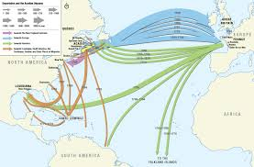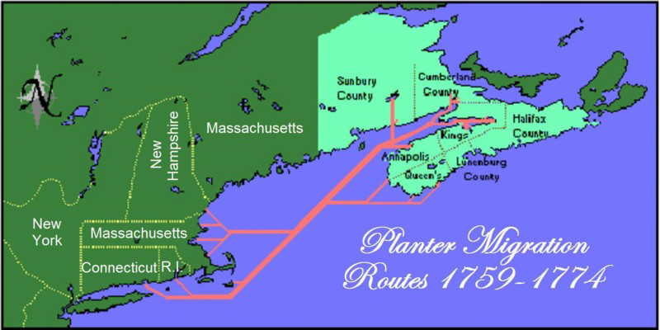
Deported Acadians were resettled on Eastern shore of The Planters came from Massachusetts, Connecticut, and
the Colonies, Central & South America, and France Rhode Island
Over fifteen of our ancestors arrived in Nova Scotia between 1760 and 1763. They left their homes in Connecticut, Massachusetts, and Rhode Island. Among these planters were David Eaton, his wife Deborah White, and their children who settled in Cornwallis; The future wife of Stephen Eaton, Elizabeth Woodworth arrived from Rhode Island with her parents Thomas Woodworth and his wife Zerviah Fox and her siblings on the “Sally” or “Lydia” Sloops and also settled in Falmouth or Cornwallis. The cost to each of the 58 passengers was 25 shillings each. In Falmouth, “the town meeting was used as the means of dividing the land and of regulating almost every activity of the community, even to the distribution of the Acadian ruins, the cutting of firewood, the earmarks for the cattle, and the use of the commons for grazing.” The DeWolf family traveled from Saybrooke, Connecticut, and settled in Wolfville in 1761. Lebbeus Harris, who married Margaret Lucilla DeWolf, arrived from Essex, Massachusetts in 1761 to settle in Cornwallis. Shippy Spurr arrived with his parents Michael Spurr and Jane Shippe on the sloop “Charming Molly” in 1760 sailing from Boston to Annapolis Royal. Nathaniel Parker, a British soldier, married Salome Whitman who also arrived with her parents Deacon John Whitman and Mary Foster on the sloop Charming Molly; Nathaniel and Salome settled in Nictaux in Annapolis County.
“On her first voyage the “Charming Molly” carried thirty-one men, two women, and twelve children, as well as stock and equipment. Most of the men left their wives and families in Massachusetts until they had prepared living quarters for them….The grantees met to appoint lot layers and other necessary officials, and so introduced the New England Town Meeting to Nova Scotia…Each head of a family received the normal share of 500 acres, and some of the low land which had been cultivated by the Acadians. Defense was provided by the garrison at Annapolis and the organization of the male settlers as militia. The building of homes went forward rapidly. Within a few years the Annapolis township had a population of 500…[More Planters arrived and] “the Granville grants extended from the river to the Bay of Fundy.”… “The chief occupation was farming, although some of the Planters became fishermen, millers, and sawyers.” “The passengers arrived weary and half sick, and fodder for the stock had been exhausted. But once on land, the settlers regained their optimism, and they were soon off to their new homes, in true pioneer fashion, driving their cattle before them.” (26-27). Initially, they lived in tents. “An outstanding characteristic of the Planter settlements in Horton and Cornwallis was the central community or Town Plot…used here also for purposes of defense, trade and social life.”
The towns in Annpolis “Valley were grouped in three pairs: Cornwallis and Horton, Falmouth and Newport, Annapolis and Granville.”
Our McPherson ancestors traveled from Edinburgh and Glasgow, Scotland to Shelburne Nova Scotia. WHO Another ancestor, Anthony Demings, reported to have been kidnapped from his homeland in Oporto, Portual or from a ship, settled in Massachusetts before coming to Shelburne, NS. WHEN
1768 – Population of Annapolis was 99 families, 8 or 10 being Acadians, for a total of 513 people. In Nova Scotia, “the Planters and Pioneers were of many types and from many places. There were nearly 3100 names listed as heads of families…The largest contingent came from Massachusetts, about 1111. The next largest group directly from England, 511 plus…404 from German principalities, 134 from Connecticut, and 98 from Rhode Island…The population by 1783, not counting the Acadians, was at least 21,000” perhaps as high as 24,000.
1770- “German, Scottish, and Irish families had arrived.”
1775-1783 - The American Revolution broke out between Great Britain and its Thirteen Colonies in North America.
1783 - Many who had remained loyal to the British Crown began to seek refuge in Canada when the Revolution ends. Roughly 35,600 Loyalists migrated to Nova Scotia.
Other of our ancestors were British soldiers who suffered grievous losses in the American Revolution and headed to Wallace, Nova Scotia. This included Isaac Akerley in 1780 and James Doherty around the same time.

Planter Ancestors Who Traveled from the New England Colonies to Nova Scotia

David Eaton and Deborah White married in on October 10, 1751 in Tolland, CT
page | Name/birth |  |  | Date/Place of Embarkation |  | Transportation |  | Settled in Nova Scotia
 | David Eaton  b. 1729: Haverhill, MA  d. 1803 Cornwallis, NS |  |  | 1760 – Tolland, CT |  |  |  | Cornwallis, NS
 | (Descendent of John Eaton and Ann who left Warwickshire, England in 1639 to come to Salisbury, MA and later Haverhill, MA) David Eaton migrated from Tolland, Connecticut to Cornwallis, NS around 1761, fifteen years before the Revolutionary War. Possibly David Eaton’s military service with the British army in Canada inspired him to relocate there.
 | DAVID EATON (James⁴, Jonathan³, Thomas², John¹)
 |  | Name/birth | Date/Place of Embarkation |  | Transportation |  | Settled in Nova Scotia
 |  | Deborah White  b. 1732: Middleton, CT  d. 1719: Annapollis, NS | 1760 – Tolland, CT |  | ship |  | Cornwallis, NS
 |  | Descendent of Elder John White & Mary Leavitt who left England in 1622 to settle first in Cambridge, MA and then Hartford, CT. They traveled on the ship “Lyon” and arrived at Massachusetts Bay Colony in 1632.
 |  | DEBORAH WHITE (Thomas⁵, Jacob^{4,} Deacon Nathaniel³, Captain Nathaniel^{2,} Elder John White¹)

STEPHEN EATON & ELIZABETH WOODWORTH married 1775 in Kentville, NS
page | Name/birth |  |  | Date/Place of Embarkation |  | Transportation |  | Settled in Nova Scotia
 | Stephen Eaton  b. 1754: Coventry. CT  d. 1838: Annapolis, NS |  |  | 1760 – Tolland, CT |  | ship
 | (Descendent of John Eaton and Ann who left Warwickshire, England in 1639 to come to Salisbury, MA and later Haverhill, Massachusetts)
 | Stephen Eaton (David⁵, James⁴, Jonathan³, Thomas², John¹)
 |  | page | Name/birth |  | Date/Place of Embarkation |  | Transportation |  | Settled in NS
 |  |  | Elizabeth Woodworth  b. 1753: Norwich, CT  d. 1841: Cornwallis, NS |  | 1760- Newport, RI |  | “Sally” or “Lydia” Sloops |  | Cornwallis, NS
 |  |  | (Descendent of Walter Woodworth who emigrated from Kent, England in 1630 to Scituate, MA, with Governor Winthrop)
 |  |  | Elizabeth’s father, Thomas Woodworth and his family arrived with twelve other families on either the “Sally” or the “Lydia,” sloops that sailed from Newport, Rhode Island to Falmouth, Nova Scotia in May 1760.
 |  |  | Elizabeth Woodworth (Thomas Wooodworth⁴ & Zerviah Fox, Isaac Woodworth³ & Ruth Douglas, Isaac Woodworth² &Lydia Stanklick, Walter Woodworth¹ & Elizabeth Tyson)

Zerviah Fox & Thomas Woodworth, parents of Elizabeth Woodworth, married in 1751 in Norwich, CT
page | Name/birth | Date/Place of Embarkation | Transportation | Settled NS
 | Zerviah Fox (twin)  b. 1726: Groton, CT  d. 1767: 1967: Cornwallis, NS | Newport, Rhode Island | It appears Zerviah Fox accompanied her husband Thomas Woodworth on sloop “Sally” or “Lydia.”She settled in Falmouth, Nova Scotia, not far from Cornwallis
 | Zerviah Fox’s ancestor, Thomas Fox (also spelled Ffoxe) was born in Concord, MA and emigrated from England before 1644. He was elected freeman of the Massachusetts Colony, possibly in 1630. His father Thomas Fox Jr emigrated from London, ENG. His ancestor Thomas Foxe was born in Bedford, ENG.
 | Zerivah Fox⁷ (John⁶, Ebenezer⁵, Isaac⁴, Thomas³, Thomas III², Thomas¹) NEEDS MORE WORK

page | Name/birth | Date/Place of Embarkation | Transportation | Settled in Nova Scotia
 | Thomas Woodworth  b. 1726: Norwich, CT  d. 1807: Falmouth, NS | May 1760, Newport RI | Arrived from Rhode Island on either “Sally” or “Lydia” Sloops | Falmouth, NS
 | (Descendent of Walter Woodworth who emigrated from Kent, England to Scituate, Massachusetts, in 1630 with Governor Winthrop) and received land grants in Cornwallis in 1760.
 | Thomas Woodworth,(Isaac Woodworth³ & Ruth Douglas, Isaac Woodworth² &Lydia Stanklick, Walter Woodworth¹ & Elizabeth Tyson)

Amos Eaton married Sarah Harris in 1810 in Cornwallis, NS
page | Name/birth |  | Date/Place of Embarkation |  | Transportation |  | Settled in Nova Scotia
 | Amos Eaton  b. 1785: Cornwallis, NS  d. 1865: Pugwash, NS |  | Left Cornwallis, NS |  |  |  | Settled in Pugwash
 | (Descendent of John Eaton and Ann who left Warwickshire, England in 1639 to come to Salisbury, MA and later Haverhill, MA)
 | Amos Eaton (Stephen ⁶, David⁵, James⁴, Jonathan³, Thomas², John¹)
 | page | Name/birth |  | Date/Place of Embarkation |  | Transportation |  | Settled in Nova Scotia town
 |  | Sarah Harris  b. 1787 Cornwallis, NS  d, 1865 Pugwash, NS |  | Left Cornwallis, NS |  |  |  | Settled in Pugwash
(Descendent of John Harris – born 1707 -- of Cotswold District, Gloucestershire, ENG or Suffolk, England who came to Essex, Massachusetts)
(In 1761, Sarah’s father Lebbeus came from New London, CT to Kings County, Nova Scotia.)
 |  | Sarah Harris (Lebbeus^{4,} James³, James², John¹)

Lebbeus Harris married Margaret Lucilla DeWolf in1769 in Horton, NS
page | Name/birth | Date/Place of Embarkation | Transportation |  | Settled in Nova Scotia
 | Lebbeus Harris  b. 1713: New London, CT  d. 1792: Wolfville, CT | 1761 | SHIP |  | Cornwallis, NS
 | (Descendent of John Harris – born 1707 -- of Suffolk, England who came to Essex, Massachusetts)
 | Lebbeus, (James³, James², John¹⁾
page | Name/birth | Date/Place of Embarkation |  | Transportation |  | Settled in Nova Scotia
 | Margaret Lucilla DeWolf  B. 1750 Middlesex, CT  d. aft 1789 Wolfville, NS | 1761 - Saybrooke, CT |  |  |  | Wolfville, NS
(Descendent of Belthazar DeWolf of Sagan – born 1620, Prussia who traveled to Old Lyme, CT).
Margaret Lucilla traveled with her father Nathan and mother Lydia Kirtland from Saybrooke, CT and they settled in Wolfville, NS. The town is named after the family.
 | Margaret Lucilla DeWolf (Nathan⁴, Josiah³, Simon², Balthazar¹⁾

Stephen Eaton married Mary Desiah Parker in 1842 in Pugwash, NS
page | Name/birth |  |  | Date/Place of Embarkation |  | Transportation |  | Settled in Nova Scotia
 | Stephen Eaton  b. 1819: Cornwallis, NS  d. 1883: Pugwash, NS |  |  | Left Cornwallis, NS |  |  |  | Settled in Pugwash, NS
 | (Descendent of John Eaton and Ann who left Warwickshire, England in 1639 to come to Salisbury, MA and later Haverhill, Massachusetts)
 | Stephen Eaton (Amos^{7,} Stephen ⁶, David⁵, James⁴, Jonathan³, Thomas², John¹)
 |  | page | Name/birth |  | Date/Place of Embarkation |  | Transportation |  | Settled in Nova Scotia
 |  |  | Mary Desiah Parker
 |  |  | Descendent of John (James) Parker – born 1591 of Great Burstead, Essex, ENG and Joane Drake -- born 1590 in Essex Market, ENG and came to Groton, MA and Windsor, CT.
 |  |  | Mary Desiah Parker (Nathaniel^{6,} William^{5,} Nathaniel ^{4,} Joseph W ^{3,} Captain Joseph D. ^{2,} John/James¹)

Maynard Parker (father of Mary Desiah) married Catherine Marsden Spurr in 1819 in Annapolis, NS
page | Name/birth |  |  | Date/Place of Embarkation |  | Transportation |  | Settled in Nova Scotia
 | Rev. Maynard Parker  b. 1795 Annapolis, NS  d. 1860 Pugwash, NS |  |  | Left Annapolis, NS |  |  |  | Settled in Pugwash, NS
 | Descendent of John (James) Parker – born 1591 of Great Burstead, Essex, ENG and Joane Drake -- born 1590 in Essex Market, ENG and came to Groton, MA and Windsor, CT.
 | Maynard Parker (Mary⁷, Nathaniel^{6,} William^{5,} Nathaniel ^{4,} Joseph W ^{3,} Captain Joseph D. ^{2,} John/James¹)
 |  |  | Name/birth |  | Date/Place of Embarkation |  | Transportation |  |  | Settled NS
 |  |  | Catherine Marsden Spurr  b.1802  d. 1852 |  | Left Annapolis, NS. |  | Father Shippy Spurr traveled on “Charming Molly” in 1760 |  | Settled in Pugwash, NS
(Descended from Robert Spurr – born abt. 1611 in England. Sailed from Gravend, England on April 3, 1635 on the “Paul” of London and settled in Dorchester, MA).
Catherine Marsden’s father Shippy Spurr arrived with her grandfather Michael Spurr –born 1723-- and grandmother Jane Shippe, born 1727-- on the sloop “Charming Molly” in 1760, sailing from Boston to Annapolis Royal.
 |  |  | Catherine Marsden Spurr (Shiipy⁵, Michael⁴, Ensign Thomas³, Lt.Col. Robert², Robert ¹)

Nathaniel Parker (father – Maynard) married Salome Whitman in 1779 Annapolis, NS
page | Name/birth |  |  | Date/Place of Embarkation |  |  | Transportation | Settled in Nova Scotia
Nathaniel Parker
1743: Dorchester, MA
1830: Annapolis, NS
 | Descendent of John (James) Parker – born 1591 of Great Burstead, Essex, ENG and Joane Drake -- born 1590 in Essex Market, ENG and came to Groton, MA & Windsor, CT.
 | Nathaniel Parker (William^{5,} Nathaniel ^{4,} Joseph W ^{3,} Captain Joseph D. ^{2,} John/James¹)
 |  | page | Name/birth |  | Date/Place Embarkation | Transportation |  |  | Settled in Nova Scotia
 |  |  | Salome Whitman  b. 1755 Stow, MA  d. 1831Annapolis, NS |  | Stow, MA | Father John Whitman arrived in May, 1760 on “Charming Molly to Annapolis. Mother Mercy Foster arrived in June, 1760 on “Confidence” with all their children including Salome. |  |  | Annapolis, NS
 |  |  | (Descended from Dr. Richard Palgrave of Barnham Brook, Wymondham, ENG who traveled to Charlestown, MA in 1630. Dr. Richard Palgrave was descended from Edward 1, King of England – born 1272—an Eleanor of Castile – born 1244.)
 |  |  | Salome Whitman (Deacon John⁵, John⁴, Rev. Zechariah³ married to Sarah Alcock^{3,} Sarah Palgave^{2,} Richard Palgrave¹)

William Parker (father-Nathaniel) m Mary Maynard in Shrewsbury, MA 1739
page | Name/birth |  |  | Date/Place of Embarkation |  | Transportation |  | Settled in Nova Scotia
William Parker
b. 1716: Groton, MA
d. 1748: Shrewsbury, MA
 | (Descendent of John (James) Parker – born 1591 of Great Burstead, Essex, ENG and Joane Drake -- born 1590 in Essex Market, ENG and came to Groton, MA and Windsor, CT.)
 | Williaml Parker (Nathaniel ^{4,} Joseph W ^{3,} Captain Joseph D. ^{2,} John/James¹)
 |  | page | Name/birth |  | Date/Place of Embarkation |  | Transportation |  | Settled in NS
Mary D. Maynard
b. 1719 Middlesex, MA
d. 1747 MA
 |  |  | (Descended from John Maynard, born in England and emigrated to Sudbury, MA
 |  |  | Mary D. Maynard (William Nutting⁵, Simon Jr4, Simon³, John², John¹)

Joseph Howe Eaton married Mary Adelia McPherson in Amherst, NS in 1871
page | Name/birth |  |  | Date/Place of Embarkation |  | Transportation |  | Settled in Nova Scotia
 | Joseph Howe Eaton  b. 1849 Pugwash, NS  d. 1932 York Mills, ON |  |  | Lived in Pugwash, NS |  | modern
 | (Descendent of John Eaton and Ann who left Warwickshire, England in 1639 to come to Salisbury, Massachusetts and later Haverhill, Massachusetts) His great-great grandparents came from Haverhill, MA to Cornwallis, NS
 | Joseph Howe Eaton (Stephen⁸ , Amos^{7,} Stephen ⁶, David⁵, James⁴, Jonathan³, Thomas², John¹)
 |  | page | Name/birth |  | Date/Place of Embarkation |  | Transportation |  | Settled in Nova Scotia
 |  |  | Mary Adelia McPherson  b. 1852 Pugwash, NS  d. 1922 Victoria Cross, NS |  | Lived in Pugwash |  | modern
 |  |  | (Descendent of Donald McPherson –born 1766 in Glasgow, Scotland. Great grandfather Lauchlan McPherson may have come from Scotland to Shelburne with his wife Elizabeth Urquhart – born 1767 in Edinburgh, Scotland.)
 |  |  | Mary Adelia McPherson (John Wesley⁴, Evan³, Lauchlan², Donald¹)

John Wesley McPherson married Phoebe Akerley in 1898 in Pugwash, Nova Scotia
page | Name/birth |  |  | Date/Embarkation | Transportation |  | Settled in Nova Scotia
 | John Wesley McPherson  b. 1829 Pugwash, NS  d. 1888 Pugwash, NS |  |  | Lived in Pugwash, NS
 | (Descendent of Donald McPherson –born 1766 in Glasgow, Scotland. Great grandfather Lauchlan McPherson may have come from Scotland to Shelburne with his wife Elizabeth Urquhart – born 1767 in Edinburgh, Scotland.)
 | John Wesley McPherson (Evan³, Lauchlan², Donald¹)
 |  | page | Name/birth | Date/Place of Embarkation |  | Transportation |  | Settled NS
 |  |  | Phoebe Akerley  b. 1830 River Phillip, NS  d. 1898 Pugwash, NS | Stay in Pugwash area always. Father Isaac Akerley arrived in Cumberland County in 1780 after the Revolution. |  |  |  | Remsheg or Wallace, NS.
 |  |  | (Descendent of Isaac Akerley Sr. from West Chester, New York. Her father Isaac Akerley Jr, who fought in the Revolution with Colonel Delancey in Dorchester, NY and settled in Wallace area settled in Cumberland Country with many other Loyalists around 1783.
 |  |  | Phoebe Akerley (Isaac Jr.^{2,} Isaac Sr ¹)

ISAAC AKERLEY MARRIED ?????
Isaac Akerley  b. 1755: West Chester, NY  d. 1852 | NEEDS CLARIFICATION

Isaac Akerley married Esther Doherty (daughter of James Doherty) in Wallace, NS.
page | Name/birth |  |  | Date/Place of Embarkation |  | Transportation |  | Settled in Nova Scotia
Isaac Akerley
b.
d.
 | (Descendent of Isaac Akerley Sr. from West Chester, New York. Her father Isaac Akerley Jr, who fought in the Revolution with Colonel Delancey in Dorchester, NY and settled in Wallace area settled in Cumberland Country with many other Loyalists around 1783.
 | Isaac Akerley (Isaac^{3,} Isaac² , Isaac¹)
 |  | page | Name/birth |  | Date/Place of Embarkation |  | Transportation |  | Settled NS
Esther Doherty
b. 1804: NS
d. 1884: Wallace Bay, NS
 |  |  | Descended from Colonel James Doherty who came to Wallace area after the American Revolution.

Evan McPherson – father of John Wesley – married Eliza Demings -daughter of Anthony Demings and Hannah Almira Morris
page | Name/birth |  |  | Date/Place of Embarkation |  | Transportation |  | Settled in NS
Evan McPherson
b. 1792: Shelburne, NS
d. 1887: Shelburne, NS
 |  | page | Name/birth |  | Date/Place of Embarkation |  | Transportation |  | Settled NS
 |  |  | Eliza Demings  b. 1794 Shelburne, NS  d. 1866; Shelburne, NS |  | Stayed in Shelburne, NS
 |  |  | (Descended from Anthony Demings of Oporto Portgal. After being kidnapped off boat, he lived in Massachusetts before coming to Shelburne, NS
 |  |  | Eliza Demings (Anthony2, Anthony¹)

Hannah Almira Morris – mother of Eliza Demings – married Anthony Demings
 | Hannah Almira Morris  b. 1773: Halifax, NS  d. 1806: Shelburne, NS |  |  | Her father Charles came from Boston |  |  | Settled in Halifax before moving to Wallace, NS
 | Descended from Charles Morris –born 1650 in Wales. His son, Charles Morris came from Briston, England to Boston, MA in 1730. Son Charles Morris was surveyor general of Halifax and married Mary Reed, daughter of Attorney General John Reed of Boston. Between 1748-1749 helped established Halifax and Lunenburg after explored Annapolis Royal for its benefits of settling. His granddaughter was Hannah Morris.
 | Hannah Almira Morris (Alexander^{4,} Governor Charles³, Charles_{2,} Charles¹)
 |  | page | Name/birth | Date/Place of Embarkation |  | Transportation |  | Settled NS
 |  |  | Anthony Demings  b. 1766 Manchester, MA  d. Shelburne, NS | then Manchester, MA |  |  |  | Shelburne, NS
 |  |  | (Descended from Anthony Demings of Oporto Portgal. After being kidnapped off boat, he lived in Massachusetts before coming to Shelburne, NS. He acted as pilot to the ships bearing the Planters.

JAMES DOHERTY married MARY SWEENEY IN ????????
page | Name/birth |  |  | Date/Place of Embarkation |  | Transportation |  | Settled in Nova Scotia
James Doherty
b. 1758 ?????
d. 1815: Pugwash, NS
 | (Descendent of
 |  | page | Name/birth |  | Date/Place of Embarkation |  | Transportation |  | Settled NS

“The Coming of the New England Planters to the Annapolis Valley,” R. S. Longley, 1960 (Department of History, Acadia University).
In “The Coming of the New England Planters to the Annapolis Valley” Qtd in The Coming of the Planters (14) based on H. L. Osgood, American Colonies in the Seventeenth and Eighteenth Centuries, 7 Vols (New York, 1904-25) passim. Simeon Perkins, Diary, ed. H. Innis (Champlain society, 1948), 88.
Ibid.
Steves, Rick, New England Before Europeans – the Native Americans, Steve’s Travel Guide, 2014
Marr, John S., & Cathey, John T. “New Hypothesis for Cause of Epidemic among Native Americans, New England, 1616–1619,” Emerging Infectious Diseases, 2010
Steves, Rick, “New England Before Europeans – the Native Americans,” Steve’s Travel Guide, 2014
English Settlements in America, Creating New Social Orders: Colonial Societies, 1500-1700, lumenlearning courses
Map © 2008 DeLorme (www.delorme.com) TOPO USA® – Annotations by Rick Steves
English Settlements in America, Creating New Social Orders: Colonial Societies, 1500-1700, lumenlearning courses
New England Before Europeans – the Native Americans, Steve’s Travel Guide, 2014
Canada: A Country by Consent. http://www.canadahistoryproject.ca/1500/index.html
A Tribute to Mi’kmaq History Month: The Truth and Reconciliation process is breathing Mi’kmaq Humanities into academia, Nancy MacDonald
“Map of First Nations in Nova Scotia,” A Tribute to Mi’kmaq History Month: The Truth and Reconciliation process is breathing Mi’kmaq Humanities into academia https://www.dfa.ns.ca/news-events/blog?c=a-tribute-to-mi-kmaq-history-month-the-truth-and-reconciliation-process-is-breathing-mi-kmaq-humanities-into-academia By Nancy MacDonald, DFA Executive Committee Member and Chair of DFA’s Aboriginal Caucus Committee
French-Canadian Genealogical Society, fcgsc.org
A Tribute to Mi’kmaq History Month: The Truth and Reconciliation process is breathing Mi’kmaq Humanities into academia, Nancy MacDonald
The Forgotten Immigrants: The Journey of the New England Planters to Nova Scotia, 1759-1768 by Western University's MA Public History Program Students
“The Coming of the New England Planters to the Annapolis Valley,” R. S. Longley, April 1960, 21 (Read before the Nova Scotia Historical Society), information from the Public Archives of Nova Scotia, Minutes of Council, 18 May, 1759)
Ibid, 24-25
The New England Planters: Planter Studies Home Page. http://ace.acadiau.ca/history/plstcntr.htm
“The Coming of the New England Planters to the Annapolis Valley,” R. S. Longley, April 1960, 21 (Read before the Nova Scotia Historical Society), information from the Public Archives of Nova Scotia, Minutes of Council, 18 May, 1759), 28
“The Coming of the New England Planters to the Annapolis Valley,” R. S. Longley, April 1960, 21 (Read before the Nova Scotia Historical Society), information from the Public Archives of Nova Scotia, Minutes of Council, 18 May, 1759), 26
Ibid.
Planters and Pioneers Nova Scotia, 1749 to 1775 Revised Edition
“Conclusion.” Planters and Pioneers Nova Scotia, 1749 to 1775 Revised Edition
Planters and Pioneers Nova Scotia, 1749 to 1775 Revised Edition
Genealogical Sketch of the Nova Scotia Eatons, Arthur Wentworth Hamilton Eaton, 23
The History of Haverhill, Massachusetts: From Its First Settlement, in 1640 to… George Wingate Chase, 354.
Hodge Genealogy from North American Family Histories, 1500-2000
Genealogical Sketch of the Nova Scotia Eatons, Arthur Wentworth Hamilton Eaton, 23
U.S. and Canada, Passenger and Immigration Lists, Index, 1500s-1900s, “The Rhode Island Emigration to Nova Scotia” by Ray Greene Huling in the Narragansett Historical Register, vol. 7:2 (Apr. 1889), pp. 101-136. Note pages 134 and 128 for references to Thomas Woodworth. Refer to 106 and 107 for ship names and land grants received.
Thomas Fox of Concord, New Hampshire and his Descendants, William Freeman Fox, Albany, Lyon Co, 1909, 18
Thomas Fox of Concord, New Hampshire and his Descendants, William Freeman Fox, Albany, Lyon Co, 1909, 15-16
Descendants of Walter Woodworth of Scituate, Mass, William Atwater Woodworth, 1844, 26.
Genealogical Sketch of the Nova Scotia Eatons, Arthur Wentworth Hamilton Eaton, 23
Genealogical Sketch of the Nova Scotia Eatons, Arthur Wentworth Hamilton Eaton, 23
Genealogical Sketch of the Nova Scotia Eatons, Arthur Wentworth Hamilton Eaton, 23

